

***Counseling Orphans, Promoting Empowerment (COPE)***

**Craig Moxley**

**March 2014**

I knew right away that the only way COPE could survive would be if Robinah managed the entire program. She alone could demand respect from the counselors, the vendors who we purchased materials from, and the various government officials we interacted with on a regular basis. However, she had been working as my translator for two months. The power dynamic was strongly skewed in my favor. Robinah had actually spent six years as a translator for western researchers. She was a veteran when it came to taking a backseat to issues she actually knew more about.

Together, we were about to start a *working for* program for community-based orphans and vulnerable children in Uganda, but to do so, I had to *work with* Robinah and my other community contacts to build a sustainable program. Through my work with COPE, I may have disempowered some groups – specifically adult members of Naama Parish – but we were also able to provide needed services to an at-risk population in a manner that simultaneously empowered leadership from Mityana town and Kampala.

*Forming COPE*

I entered Naama as a student researcher through DGHI fieldwork program. DGHI chose the site that I traveled to – Naama, Uganda – because of its relationship with Dr. Kigongo, a physician who was from the community who is currently spending ten years at Duke Medical before returning to Mityana, outside Naama. Dr. Kigongo asked me to follow-up on a counseling program that was created to serve community-based OVC. Largely as a result of war and the HIV/AIDS epidemic, 2 million orphaned and 8.1 million vulnerable children now live in Uganda. Many of these orphaned and vulnerable children (OVC) are treated as second-class citizens and marginalized by society due to widespread stigma. Orphans often lack adequate food, education, and medical care, in addition to suffering from emotional trauma.

When Robinah and I investigated the program, it quickly became apparent that the program was not serving OVC. The location and lack of program management (1) kept guardians from sending the children to the programs and (2) did not accomplish much in terms of improving the emotional and physical outcomes of the OVC in program. Robinah and I decided to create a new program together. Today, COPE is about to complete its second year of sessions, and it has taken the following form:

An orphan counseling program that meets for two hours bi-monthly, COPE serves over 50 community-based orphans in Naama, Uganda. COPE aims to improve the mental and physical health of orphaned and vulnerable children in Naama. COPE has a unique three-tiered structure: counselors provide psychosocial counseling, material support, and career counseling to provide participants with the tools to build a brighter future. Participants enroll in the program for one year, which includes 22 sessions. COPE’s General Manager purchases all of the services on a contract basis. Additionally, all leadership positions are based in Uganda, and the program operates on $1,500 per year.

*Working For*

COPE is able to provide counseling and material support to children in the program that they are unable to receive at home, in school, or through government provided services. Presently, there are very few organizations with the capacity to provide group-based counseling for children in Uganda. I conducted a systematic review through PubMed of every single intervention aimed at adolescents in Uganda suffering from mental health disorders and only found three studies that evaluated counseling programs for OVC, and two of the three studies measured the same intervention.[1]

Since the services we provide are not services that the children could provide themselves, employing the working for mode of engagement is the easiest and most natural method for COPE to serve its target population. Robinah and I designed the program with full knowledge that only trained counselors could administer the sessions, and Robinah, with her unique knowledge of the community and program management, was also aptly suited to manage the program. As Wells and Owen describe in *Living Without Enemies*, the relationship between COPE and its population is a professional relationship.

I have found, however, that a professional working for relationship does not come without significant costs. Two years into the program I still worry that the program could disempower the guardians of the OVC in the program. When an LC2 identifies at-risk OVC for participation in the program are sending an implicit message here that we can provide the child services that the guardians are not able to provide. Any humiliation here is exacerbated by the demographics of those who manage the program. We are outsiders. Even Robinah, from Kampala, and the counselors, from Mityana town, are outsiders.

The divide between them and us is stark in Uganda. I saw three countries in one, as there are stark differences between cities, towns, and villages. The working for model our program employed exemplifies the differences between these three Ugandas. We employ counselors from Mityana, a secretary from Mityana, a general manager from Kampala, and a student from the United States. There are no employees from Naama because they do not have the specialty that is required to provide the services. At the end of the day, COPE’s staff (especially myself!) and the children in COPE are still total strangers to each other.

I found the approach that I took with COPE to be built on the same concepts as the working for model of engagement laid out in *Why Nations Fail*. Acemeoglu and Robinson argue that inclusive institutions are the key to economic development. People with specializations in policy and development can work for a population to help create institutions that are more inclusive and representative. Just as with COPE, this approach involves one party working for another party due to differences in specialization. But, as this example was more on the macro-level, I found Mark’s experience with Reach Incorporated to be a more parallel example of working for a community, even though the program itself offers a working with opportunity. Mark identified his strengths to bring something to a community from an unequal point of power.

*Working With*

When you look at the program and the recipients of the program, it is clearly a working for program. However, when you analyze me as one party and the community as another party, I believe that it could qualify – in part – as a working with program. The diagram below illustrates these relationships:

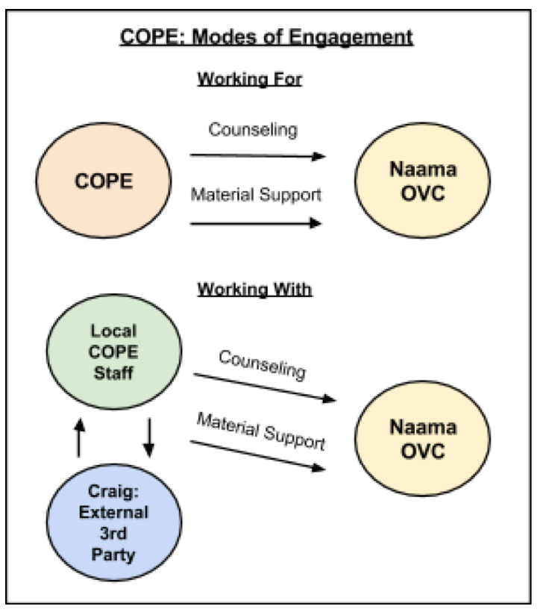

When founding the program I did not look at myself as having some set of skills that the community did not have. Rather, I tried to recognize that members of the community were much better suited to manage the program than I could ever be. They had a knowledge of the factors that would make it succeed such as the best material support to provide the children, when is the best time to have sessions, the best incentives to keep the children coming back, etc. I recognized my skills as access to research and access to funds. Thus far, I think we have done well at trying to maximize each others skill sets to work towards the common goal of working for the children in the program. Still, I oftentimes do struggle in deluding my own opinion so that Robinah feels comfortable to present her superior ideas. The fact that I have to make a conscious effort to suppress my own power in the relationship shows that we are not in an equal working with relationship.

I tried to build a working with relationship due to a focus on sustainability and inclusion that I had drilled in my head from reading about Yunus and other social enterprises. In “Poverty is a Threat to Peace,” Yunus extolls how Grameen Bank helped its poor clients by empowering them rather than serving them. When no traditional financial institution would offer loans to the poor because they were not “credit worthy,” Yunus found faith in the population; he entrusted them as recipients of loans. Then, the population was able to lift itself out of poverty. The previous summer I worked at the Social Entrepreneurship Corps and during my time at Duke I worked at CASE. Both placed a huge focus on working with community partners. I think COPE has given me the opportunity to try to not just think of serving the people I worked with in the community, but to empower them. This ended up being much harder to do than I could have ever anticipated due to power and status differences.

*Being With*

I have tried to limit my exposure to the counselors and students as much as possible as I find that it undermines Robinah’s leadership. A Duke student working in Naama this past summer actively attended sessions, playing with the kids and taking pictures of each with his large professional camera. While being with the children would give me a better understanding of the problems they face, the image it would project would be to costly. It would reinforce stereotypes that white people bring all of the resources and perpetuate images of dependency.

*Conclusion*

*“There was only one catch and that was Catch-22, which specified that a concern for one's own safety in the face of dangers that were real and immediate was the process of a rational mind. Orr was crazy and could be grounded. All he had to do was ask; and as soon as he did, he would no longer be crazy and would have to fly more missions.” Catch-22*

Like Orr, I have found my experience with COPE and the manner with which I have engaged with the community to be a Catch-22. If we want to provide the best services possible to the children in program, we need trained staff members. But, using trained staff members requires hiring people from outside of Naama and implies implicit disempowerment of other members of the Naama community. Faced with this dilemma, we must weigh the costs and benefits of our actions, with a particular focus on preserve incentives. Similarly, I want to be with the children in the program to understand their issues and suffer with them, but doing so would undermine the program’s local leadership. In the end, all I can do is try to be conscious of my implicit and explicit affects, generated from a position of power, and aim to improve the welfare of the target group while simultaneously respecting their autonomy and interests.

1. The vast majority of studies measured programs aimed at children suffering from PTSD